
CSE455 – Software Testing
Name: Aoun Haider
ID: FA21-BSE-133
Submitted to: Yella Mehroze
LAB TASK 2
- Epic, story, task and bug creation
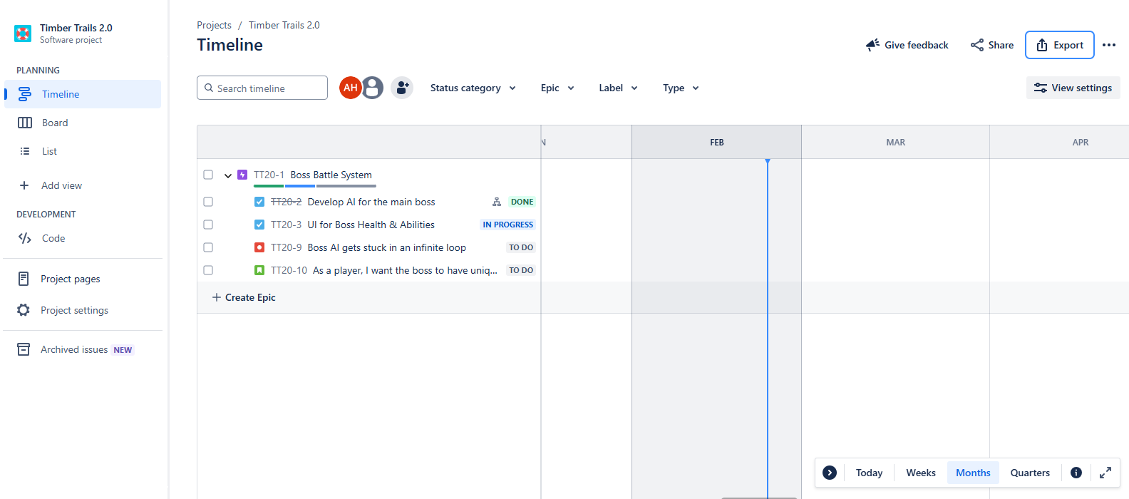
- Board adjustment for to do, in progress, done
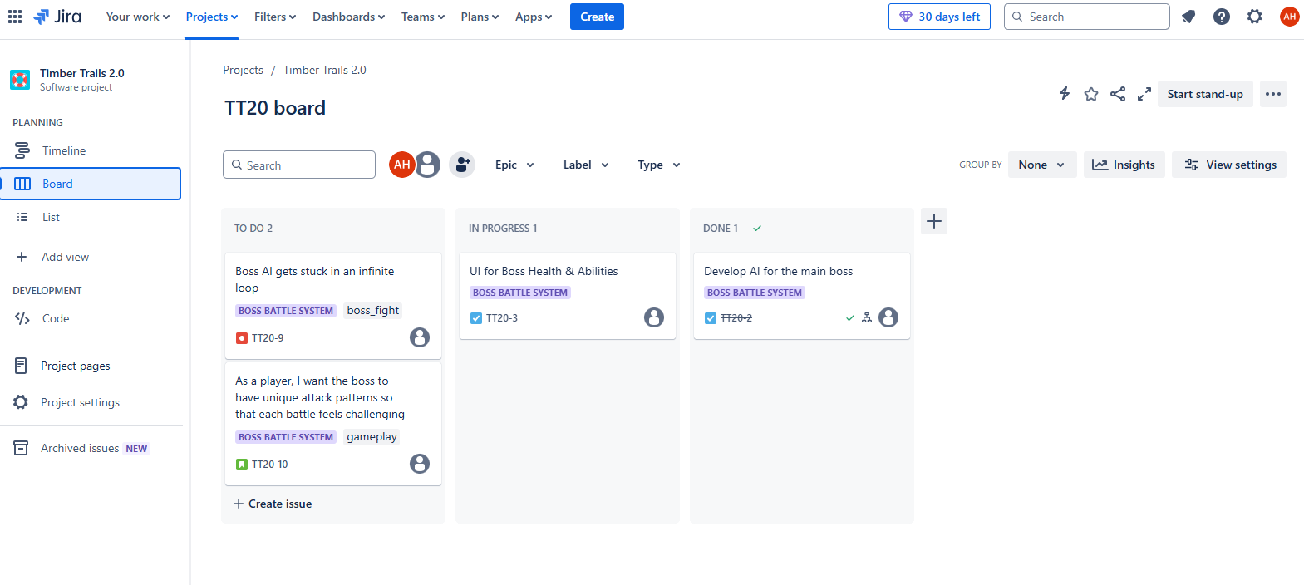

- List creation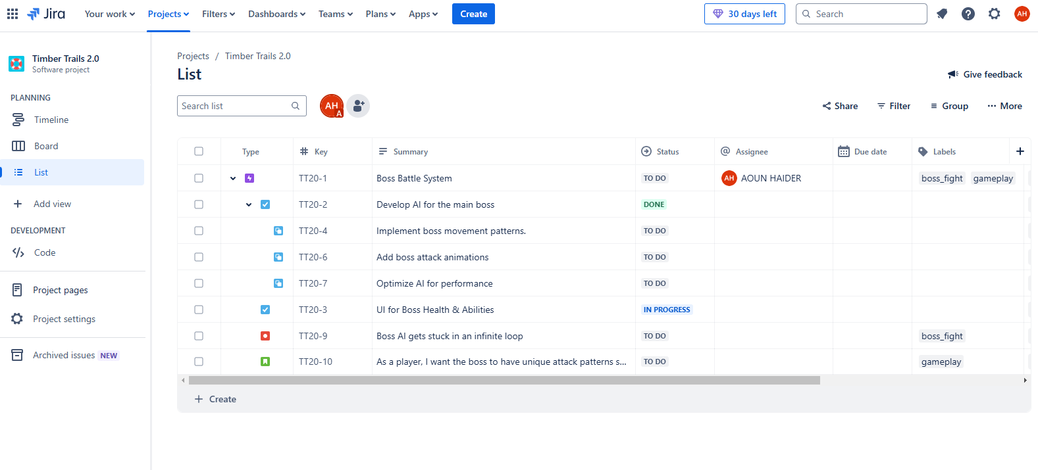
- Bug report creation
Boss Battle System (TT20-1)

[TT20-9] Boss AI gets stuck in an infinite loop Created: 23/Feb/25 Updated: 23/Feb/25
Status: | To Do
Project: | Timber Trails 2.0
Components: | None
Affects versions: | None
Fix versions: | None
Parent: | Boss Battle System

Type: | Bug | Priority: | Medium
Reporter: | AOUN HAIDER | Assignee: | Unassigned
Resolution: | Unresolved | Votes: | 0
Labels: | boss_fight
Remaining Estimate: | Not Specified
Time Spent: | Not Specified
Original estimate: | Not Specified

Rank: | 0|i0004b:

Description

- Steps to reproduce:
  - Start a battle against the "Demon King."
  - Move to the left side of the arena.
  - The boss keeps attacking in the same spot and doesn't move.
- Expected: The boss should chase the player.
- Actual: The boss gets stuck.

Generated at Sun Feb 23 16:54:43 GMT 2025 by AOUN HAIDER using Jira 1001.0.0-SNAPSHOT#100281-rev:9d28715113c712e07817c43c8ee4537bbf679688.
- Setting WIP (work in progress) limit in Kanban board:
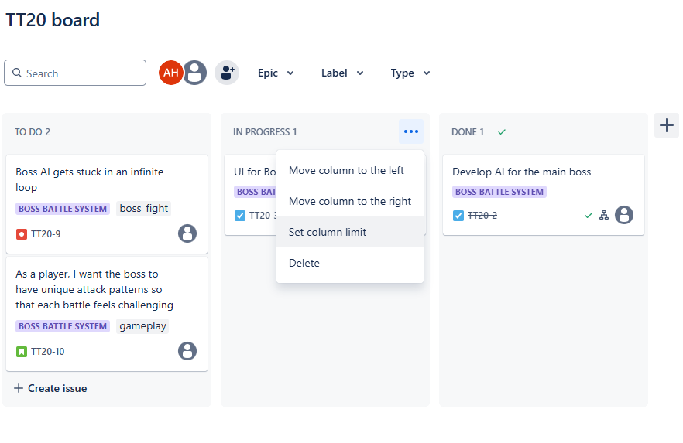
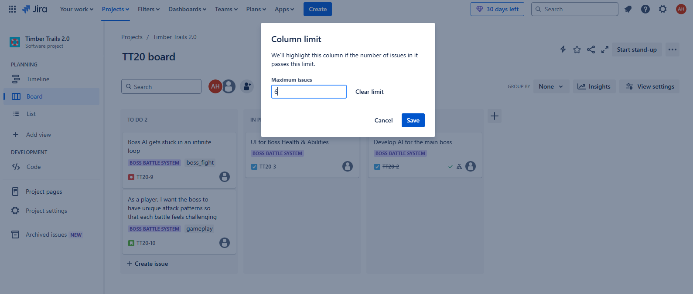
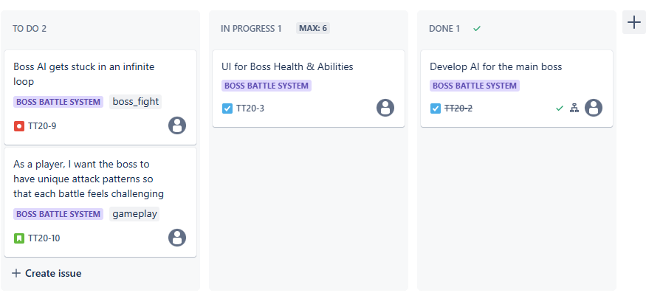
- Github integration
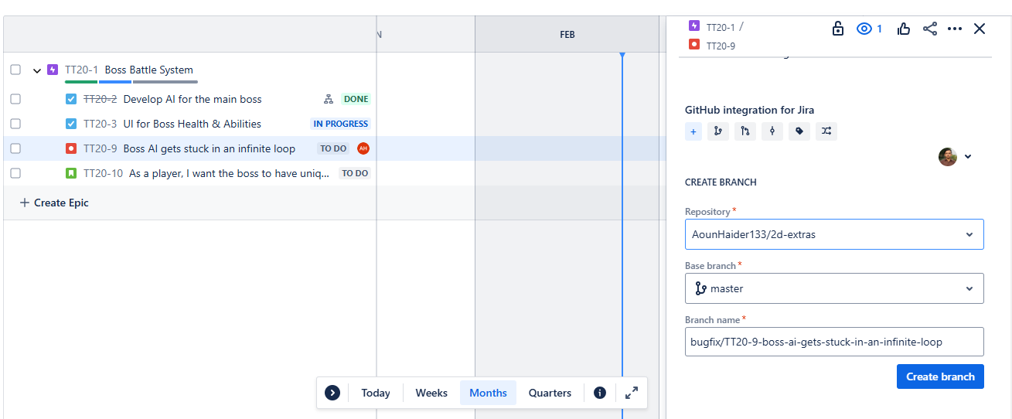
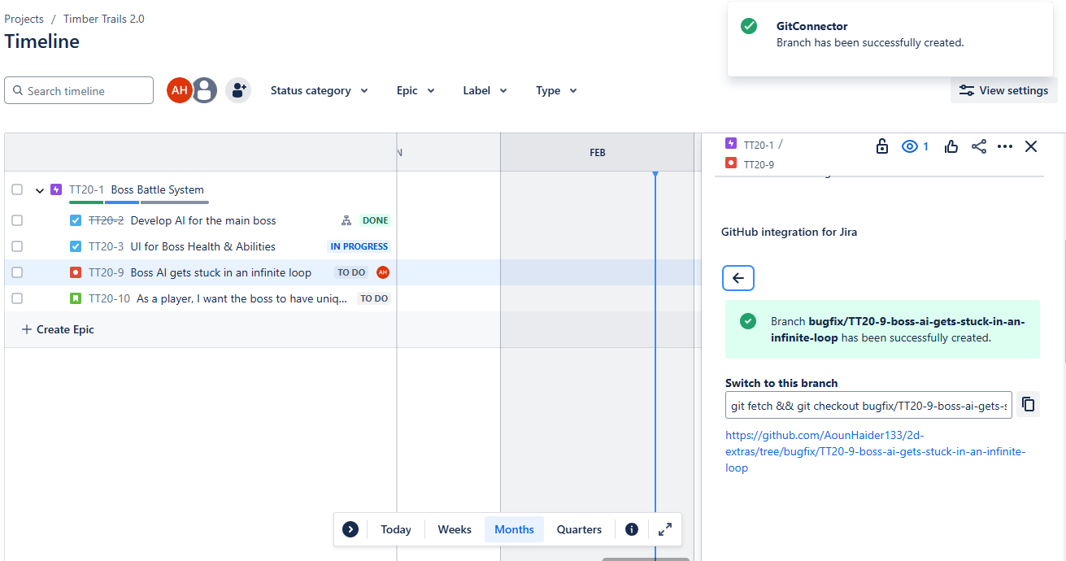
- Team creation
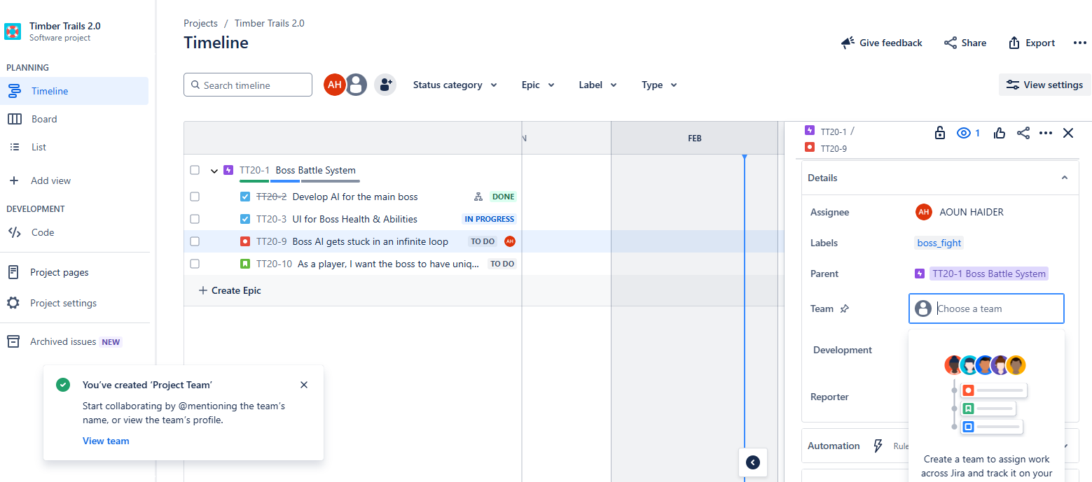

- Filter creation
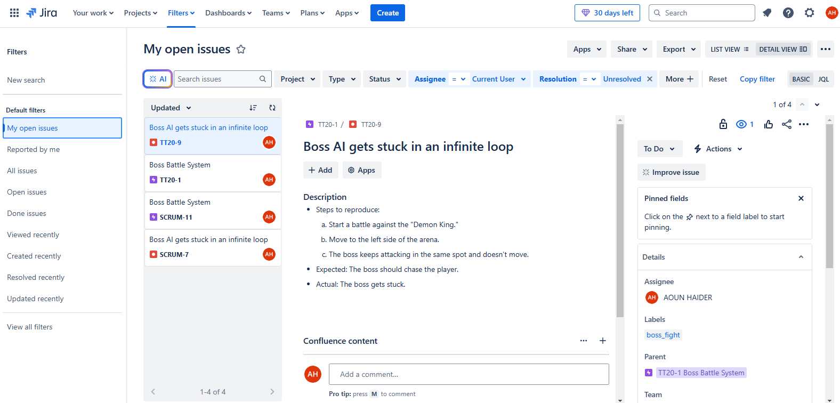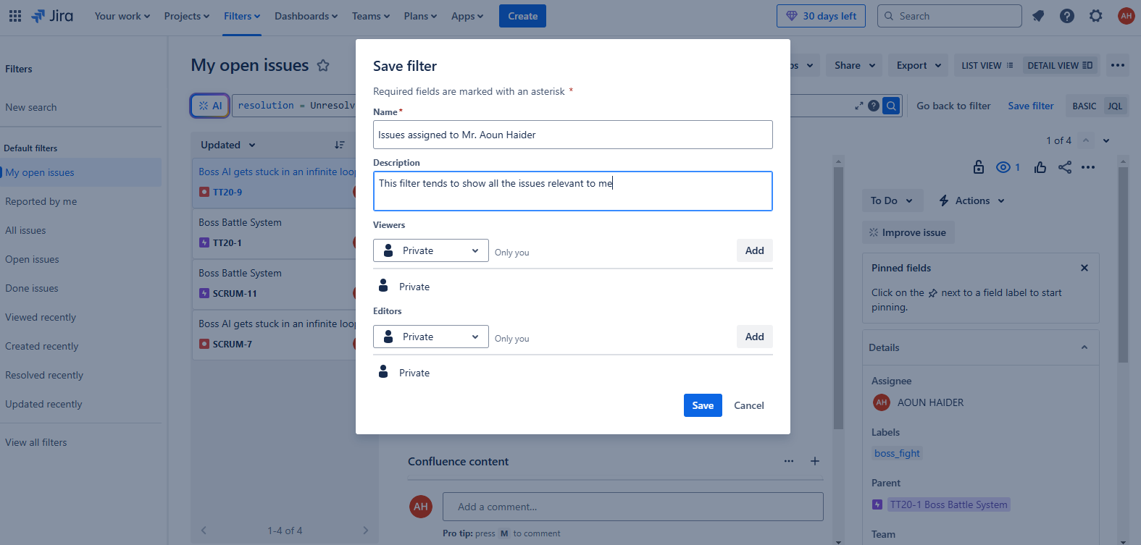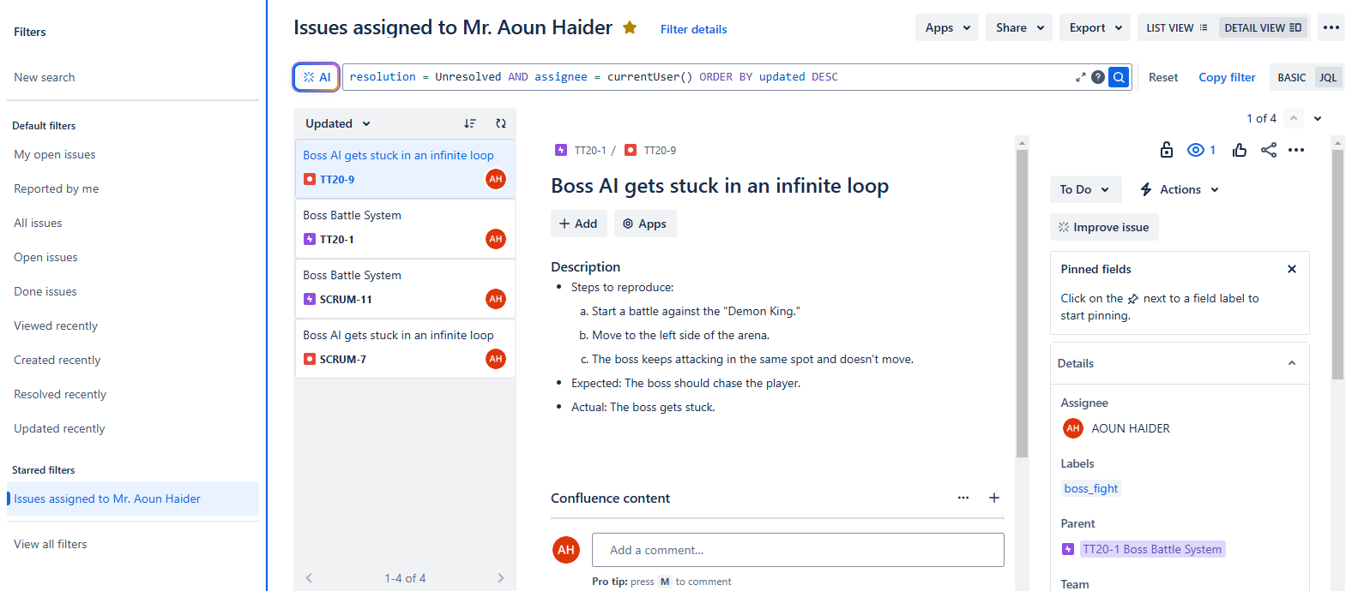

- Adjusting task priorities
